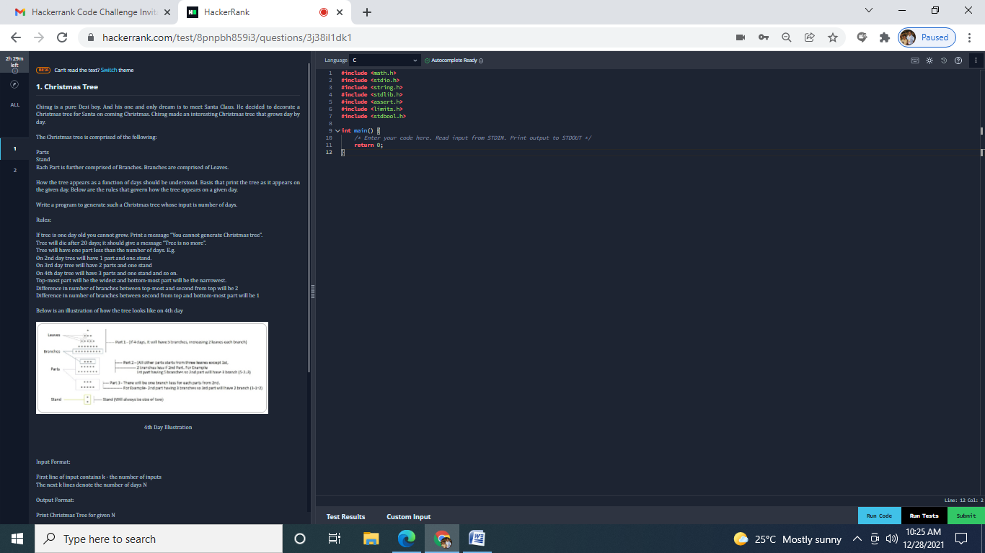

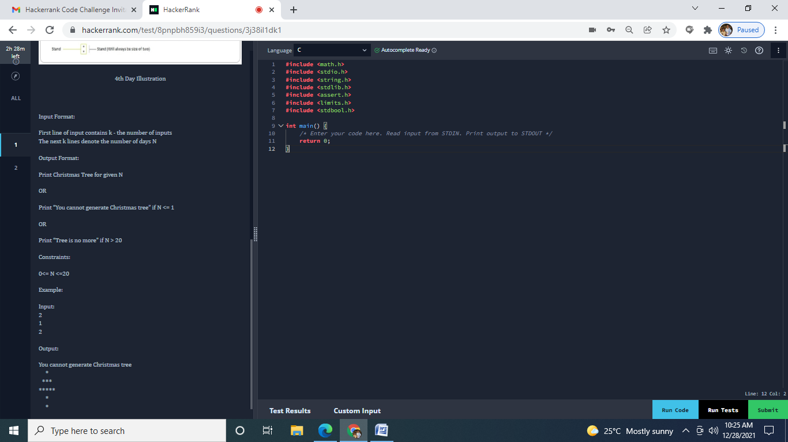

import java.util.*;

public class Main

{

public static void main(String[] args) {

int T;

int array[]=new int[10];

Scanner scan=new Scanner(System.in);

T=scan.nextInt();

for(int i1=0;i1<T;i1++)

{

array[i1]=scan.nextInt();

}

for(int i2=0;i2<T;i2++)

{

calculation(array[i2]);

}

}

static void calculation(int n)

{

if(n<=1)

{

System.out.printf("You cannot generate christmas tree\n");

}

else if(n>20)

{

System.out.printf("Tree is no more\n");

}

else

{

for(int i=0;i<n+1;i++)

{

for(int j=i;j<n;j++)

{

System.out.printf(" ");

}

for(int k=0;k<=(2*i);k++)

{

System.out.printf("*");

}

System.out.printf("\n");

}

if(n>2)

{

for(int s=0;s<n-1;s++)

{

for(int p=s;p<n-1;p++)

{

System.out.printf(" ");

}

for(int q=0;q<(2*(s+2))-1;q++)

{

System.out.printf("*");

}

for(int p=s;p<n-1;p++)

{

System.out.printf(" ");

}

System.out.printf("\n");

}

for(int t=0;t<n-3;t++)

{

for(int s=0;s<n-2;s++)

{

for(int p=s;p<n-1;p++)

{

System.out.printf(" ");

}

for(int q=0;q<(2*(s+2))-1;q++)

{

System.out.printf("*");

}

for(int p=s;p<n-1;p++)

{

System.out.printf(" ");

}

System.out.printf("\n");

}

}

}

for(int p=0;p<2;p++)

{

for(int q=0;q<n;q++)

{

System.out.printf(" ");

}

System.out.printf("*");

for(int q=0;q<n;q++)

{

System.out.printf(" ");

}

System.out.printf("\n");

}

}

}

}

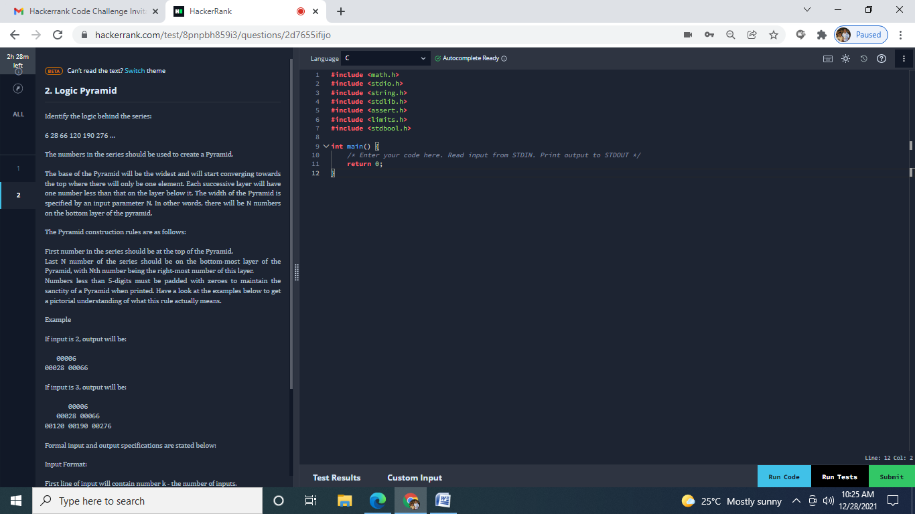

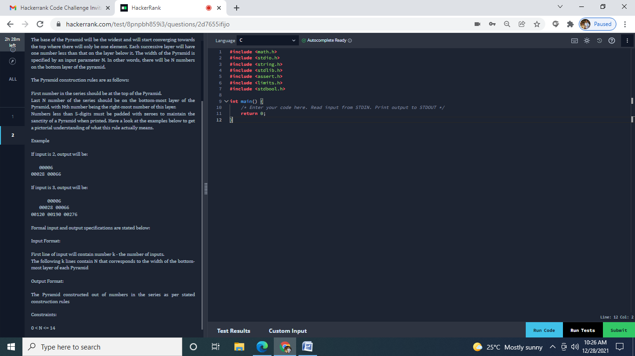

/* logic of program

first = 6, second = 28

difference = second - first

third = difference + 16 + second

first = second

second = third

*/

import java.io.BufferedReader;

import java.io.IOException;

import java.io.InputStreamReader;

/**

 *

 * @author Divyang

 */

public class LogicPyramid {

    public static void main(String[] args) throws IOException {

        BufferedReader br = new BufferedReader(new InputStreamReader(System.in));

        int n = Integer.parseInt(br.readLine()); // get the input

        if (n > 0 && n <= 14) { // condition check

            int first = 6, second = 28; // variable declare for calculation first = 6, and second = 28.

            for (int i = 0; i < n; i++) {

                for (int j = 0; j < n - i; j++) {

                    System.out.print(" "); // print space for the middle writing.

                }

                for (int k = 0; k <= i; k++) {

                    String answer = add(String.valueOf(first)); // call add function for adding zeros before text.

                    System.out.print(" " + answer); // print space after the word.

                    int diff = second - first; // find difference.

                    int ans = diff + 16 + second; // third  = difference + 16 + second

                    first = second; // first  = second

                    second = ans; // second = third;

                }

                System.out.println(); // print next line

            }

        }

    }

    static String add(String s) { //append the zero function

        StringBuffer ans = new StringBuffer();

        for (int i = 0; i < 5 - (s.length()); i++) {

            ans.append("0"); // append the zero

        }

        ans.append(s);

        return ans.toString();

    }

}

**Another Code**

import java.io.BufferedReader;

import java.io.IOException;

import java.io.InputStreamReader;

import java.util.*;

public class Main {

public static void main(String[] args) throws IOException {

int X=6,Y=22,N;

Scanner scan=new Scanner(System.in);

N=scan.nextInt();

if(N>0 && N<=14)

{

for(int i=1;i<=N;i++)

{

for(int j=i;j<N;j++)

{

System.out.print(" ");

System.out.print(" ");

System.out.print(" ");

}

for(int k=1;k<=i;k++)

{

String with5digits = String.format("%05d",X);

System.out.print(with5digits+" ");

//System.out.println(" "+X);

X=X+Y;

Y=Y+16;

}

System.out.printf("\n");

}

}

}

}

Modified Code

**import** java.io.*;

**import** java.util.*;

**import** java.text.*;

**import** java.math.*;

**import** java.util.regex.*;

**public** **class** Solution {

**static** **int** X=6,Y=22,N,T;

**public** **static** **void** main(String args[] ) **throws** Exception {

*/* Enter your code here. Read input from STDIN. Print output to STDOUT */*

**int** array2[]=**new** **int**[20];

        Scanner scan=**new** Scanner(System.in);

*//N=scan.nextInt();*

        T=scan.nextInt();

**for**(**int** i=0;i<T;i++)

        {

            array2[i]=scan.nextInt();

        }

**for**(**int** j=0;j<T;j++)

        {

            calculation(array2[j]);

        }

    }

**static** **void** calculation(**int** N)

    {

**if**(N>0&&N<=14)

        {

**for**(**int** i=1;i<=N;i++)

            {

**for**(**int** j=i;j<N;j++)

                {

                    System.out.print(" ");

                    System.out.print(" ");

                    System.out.print(" ");

                }

**for**(**int** k=1;k<=i;k++)

                {

                    String with5digits=String.format("%05d",X);

                    System.out.print(with5digits+" ");

                    X=X+Y;

                    Y=Y+16;

                }

                System.out.printf("\n");

            }

        }

        X=6;

        Y=22;

    }

}